Lab 4: Authentication Vulnerabilities (multi-factor authentication)
Objective:
- In this section, we'll look at some of the vulnerabilities that can occur in multi-factor authentication mechanisms. We've also provided several interactive labs to demonstrate how you can exploit these vulnerabilities in multi-factor authentication.
In this lab, students need to:
- Perform two challenges:
  - 2FA simple bypass
  - 2FA broken logic
- Explain and capture all steps (full windows screen capture).

Submit a report addressing all the questions mentioned above in either PDF or Markdown format. Additionally, include a video demonstrating the detailed process of your work to ensure the authenticity of your lab exercise.
The report file name must be Class_YourStudentID _YourName_Lab4
1. 2FA simple bypass
This screenshot shows the login page of the 2FA Simple Bypass lab where the user enters the username wiener and password. Burp Suite is open alongside the browser to capture and analyze the authentication requests. This step represents the initial login phase before reaching the 2FA verification stage.
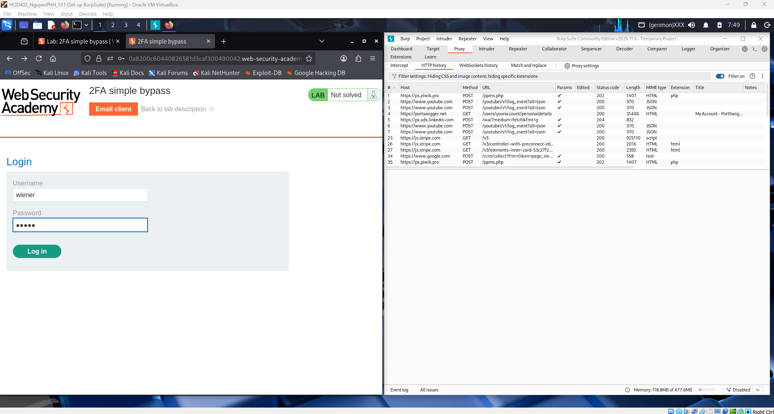
This screenshot shows the second step of authentication where the application asks for a 4-digit security code. The user has already passed the username and password stage and is now at the 2FA checkpoint. Burp Suite is monitoring traffic to analyze how the verification request is handled.
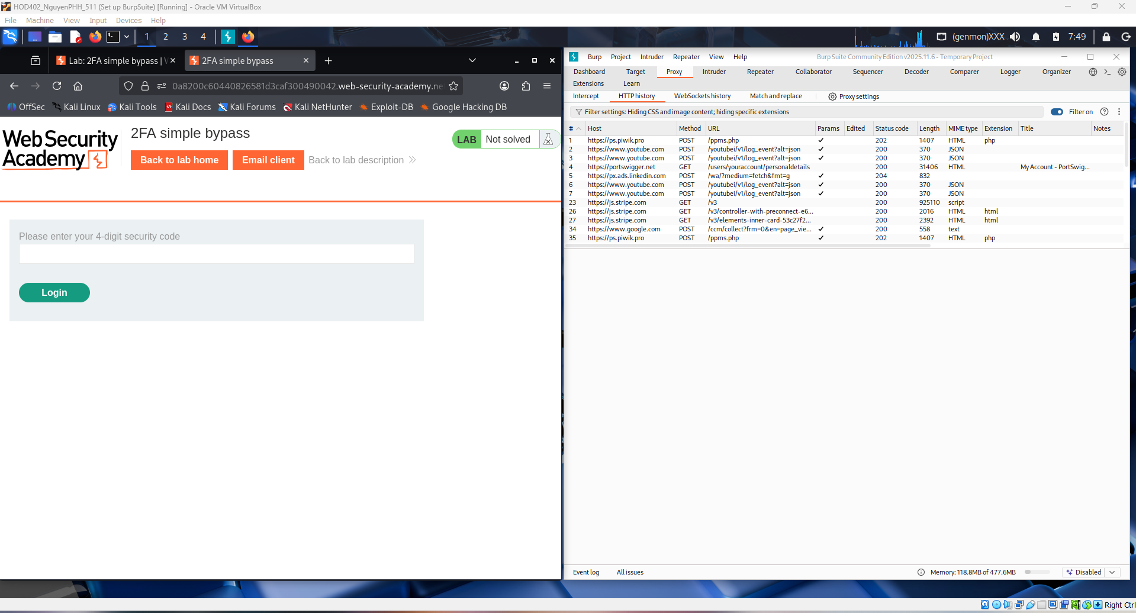
This screenshot shows the exploit server email inbox where the victim’s email messages are displayed. The system-generated email contains the 4-digit security code used for two-factor authentication. This demonstrates how the attacker can retrieve the OTP from the email to complete the login process.
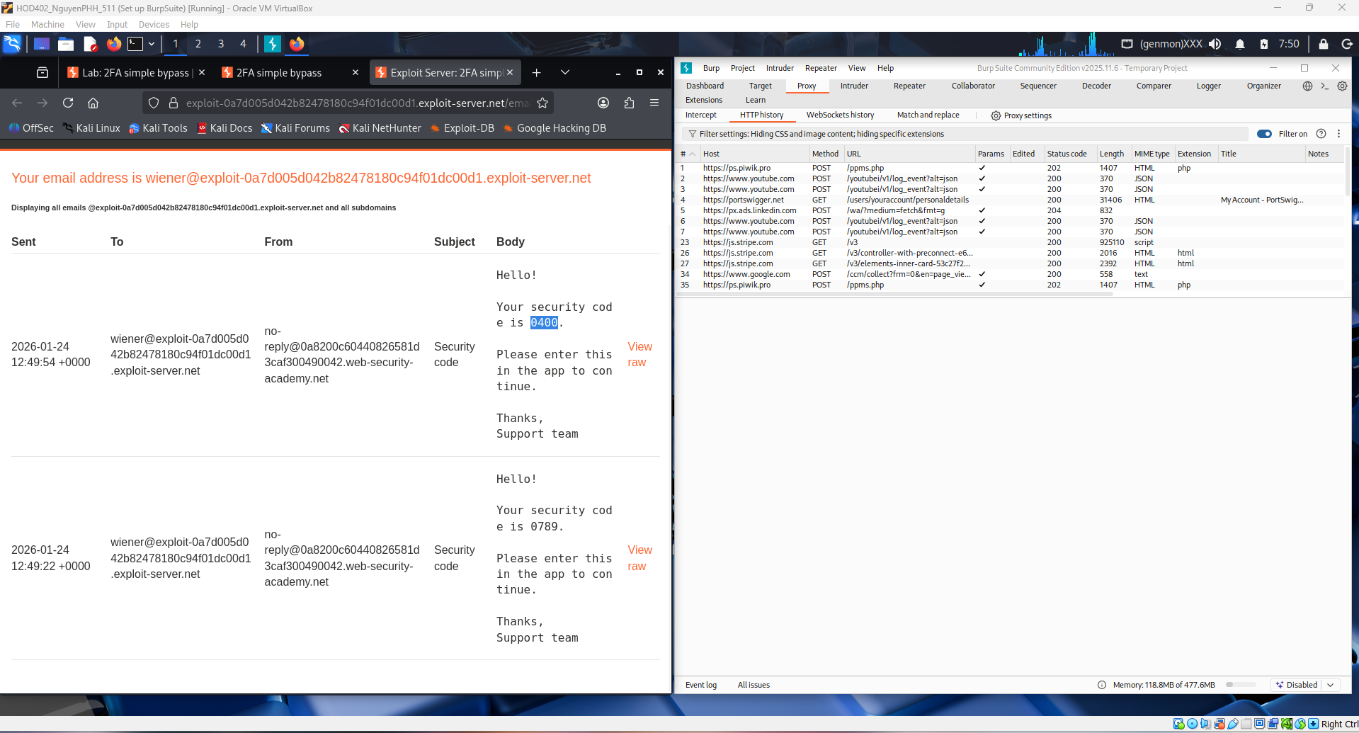
This screenshot shows a Web Security Academy lab on “2FA simple bypass” being tested with Burp Suite. The user enters a 4-digit security code while Burp captures the HTTP requests to analyze or modify the 2FA verification process. The goal is to observe how the server handles the second authentication step and identify weaknesses in the 2FA implementation.
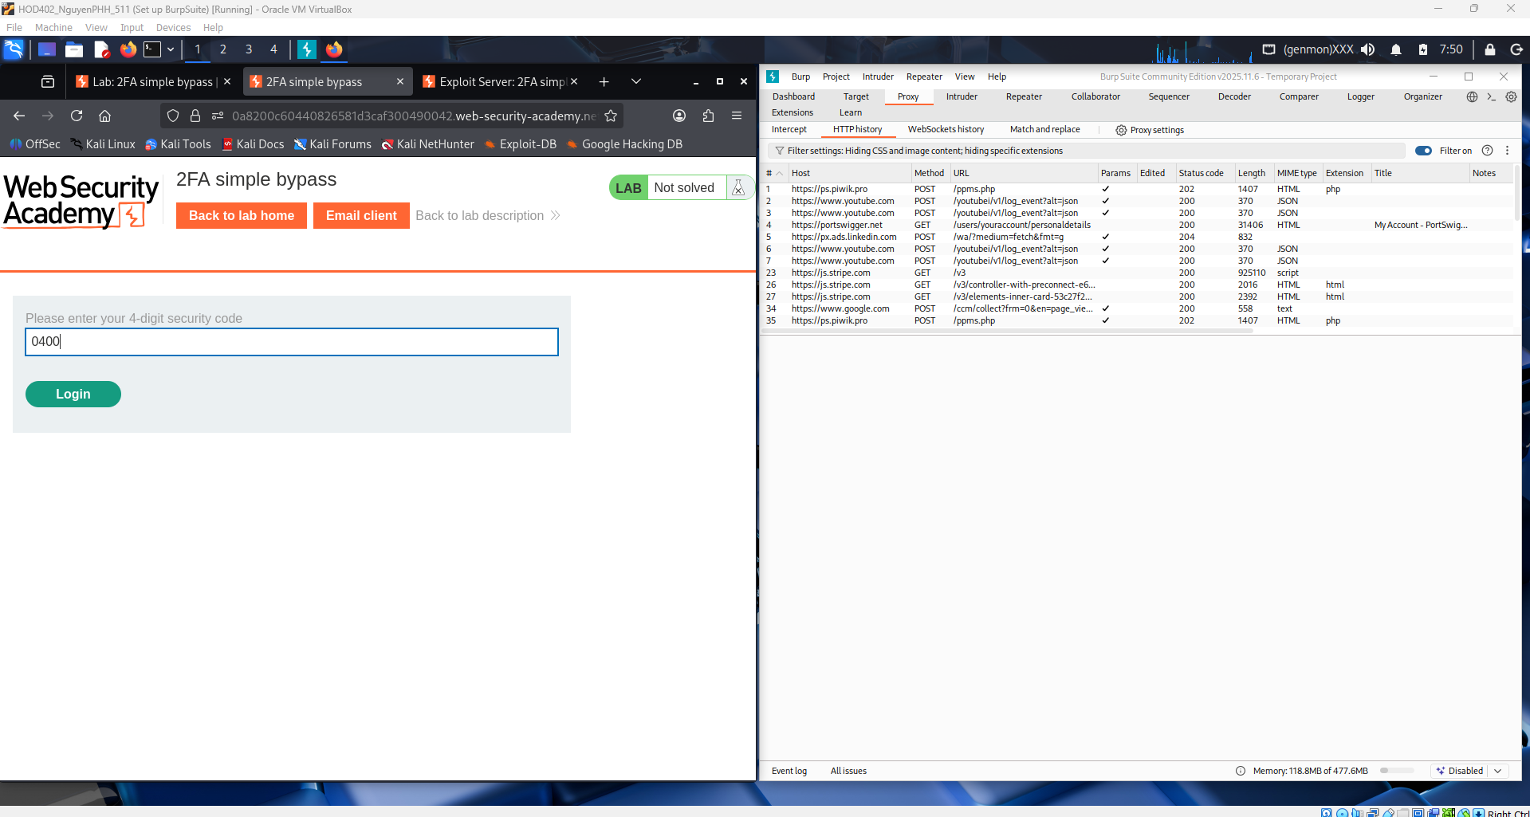
This image shows successful access to the “My Account” page in the Web Security Academy 2FA simple bypass lab. The user is logged in as wiener, indicating the second authentication step was bypassed or improperly enforced. It demonstrates a flaw where 2FA can be skipped, allowing account access without valid verification.
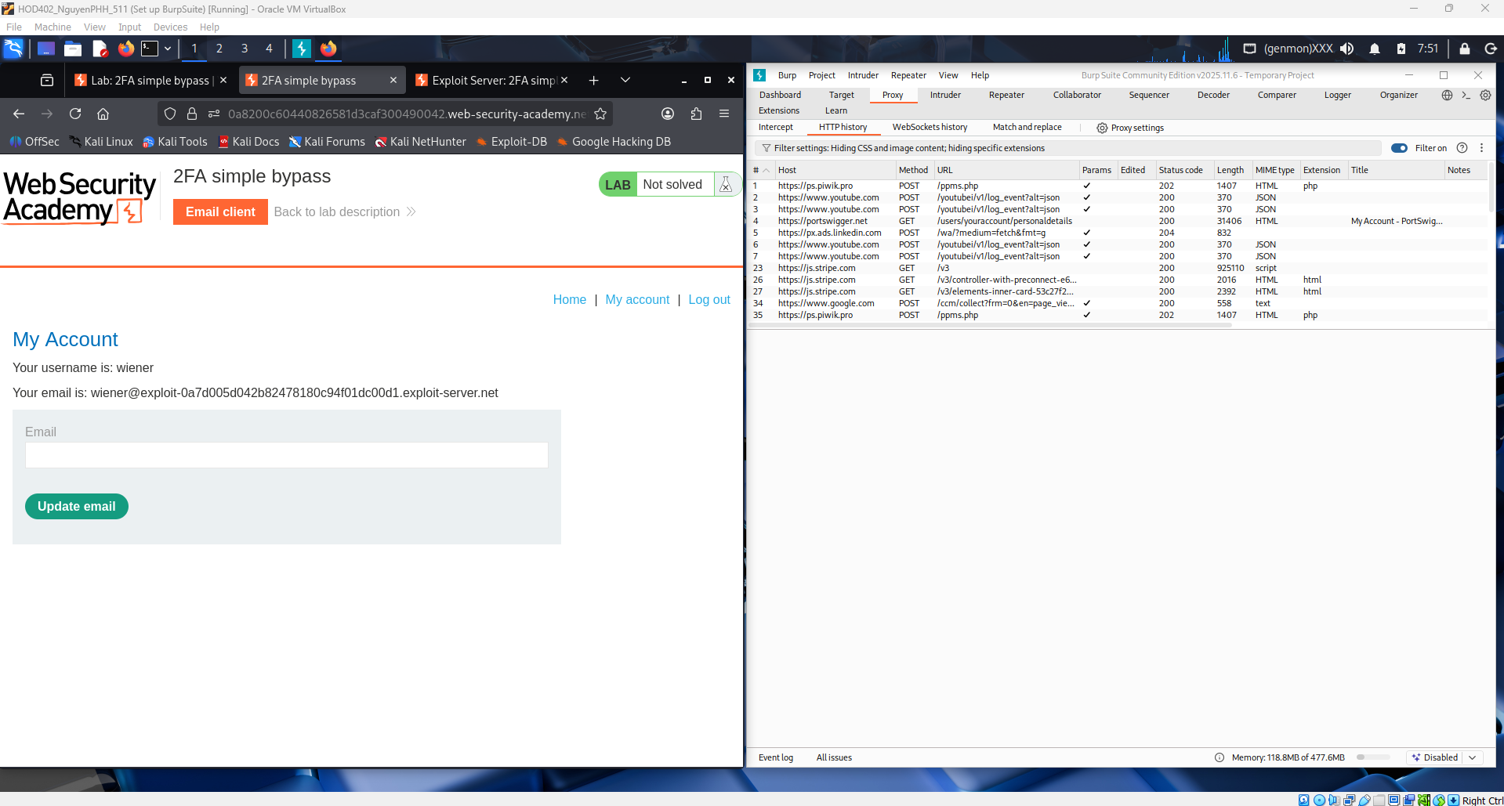
This screenshot shows the user back on the main blog page after completing the 2FA simple bypass lab The captured traffic in Burp Suite helped analyze how the 2FA step was skipped.
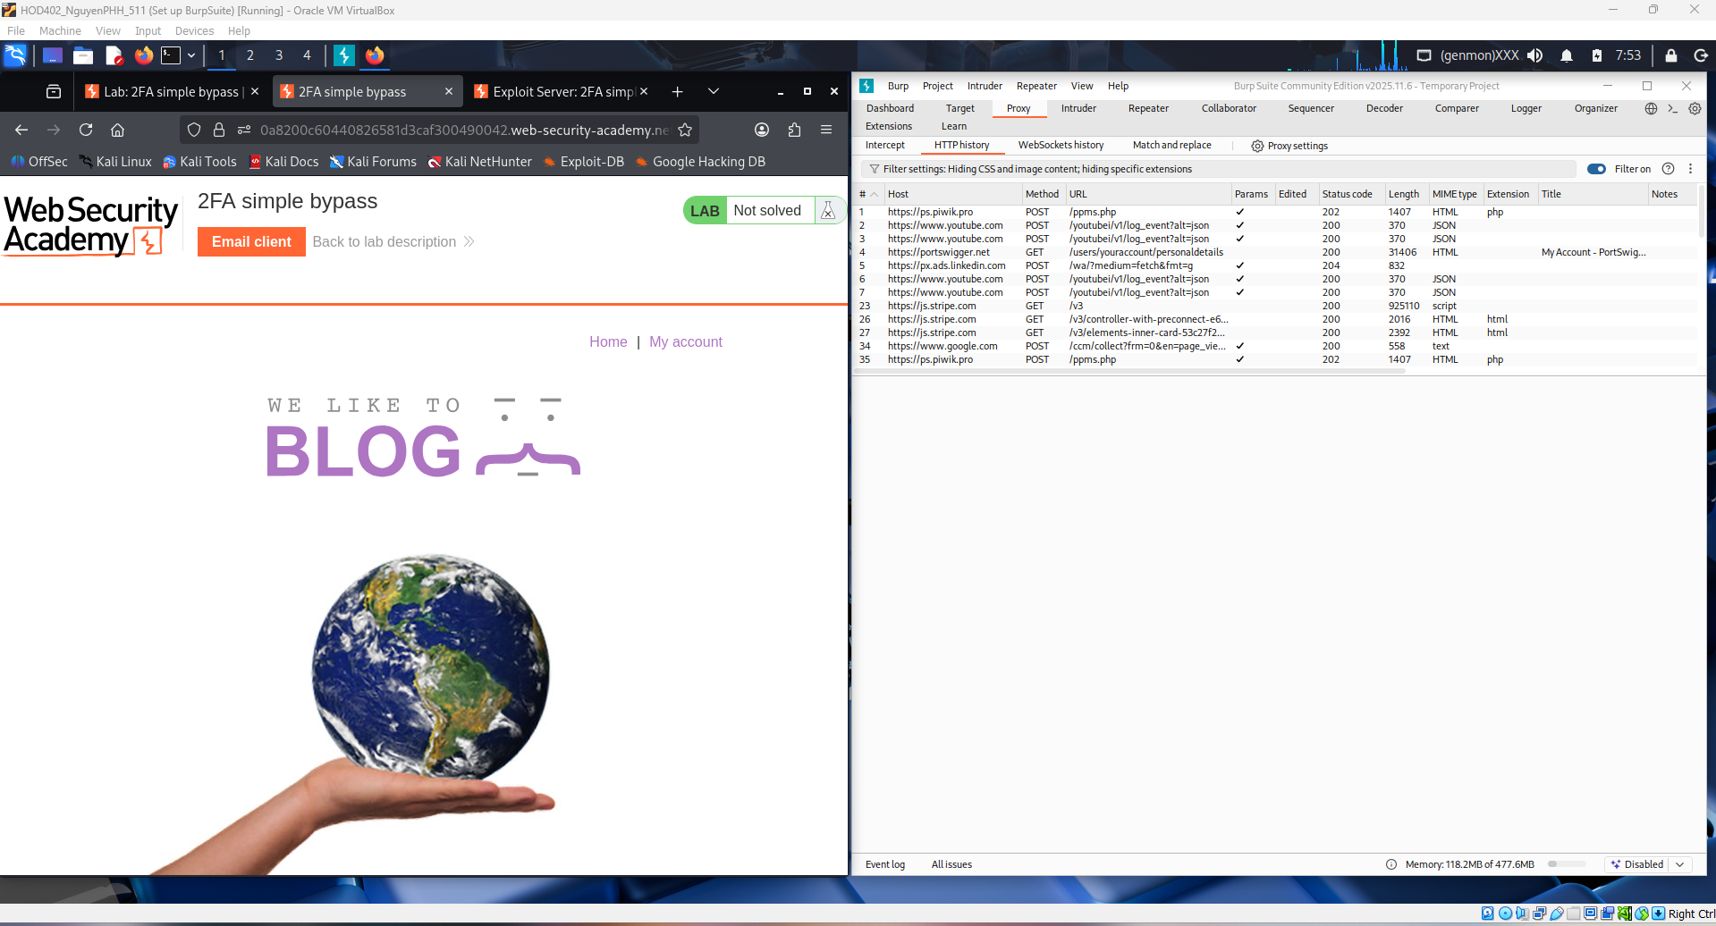
This screenshot shows the login page of the Web Security Academy 2FA simple bypass lab, where credentials (e.g., user carlos) are being submitted. Burp Suite is running to intercept the authentication requests after the username and password step. This is the first stage before the 2FA verification process that the lab later bypasses.
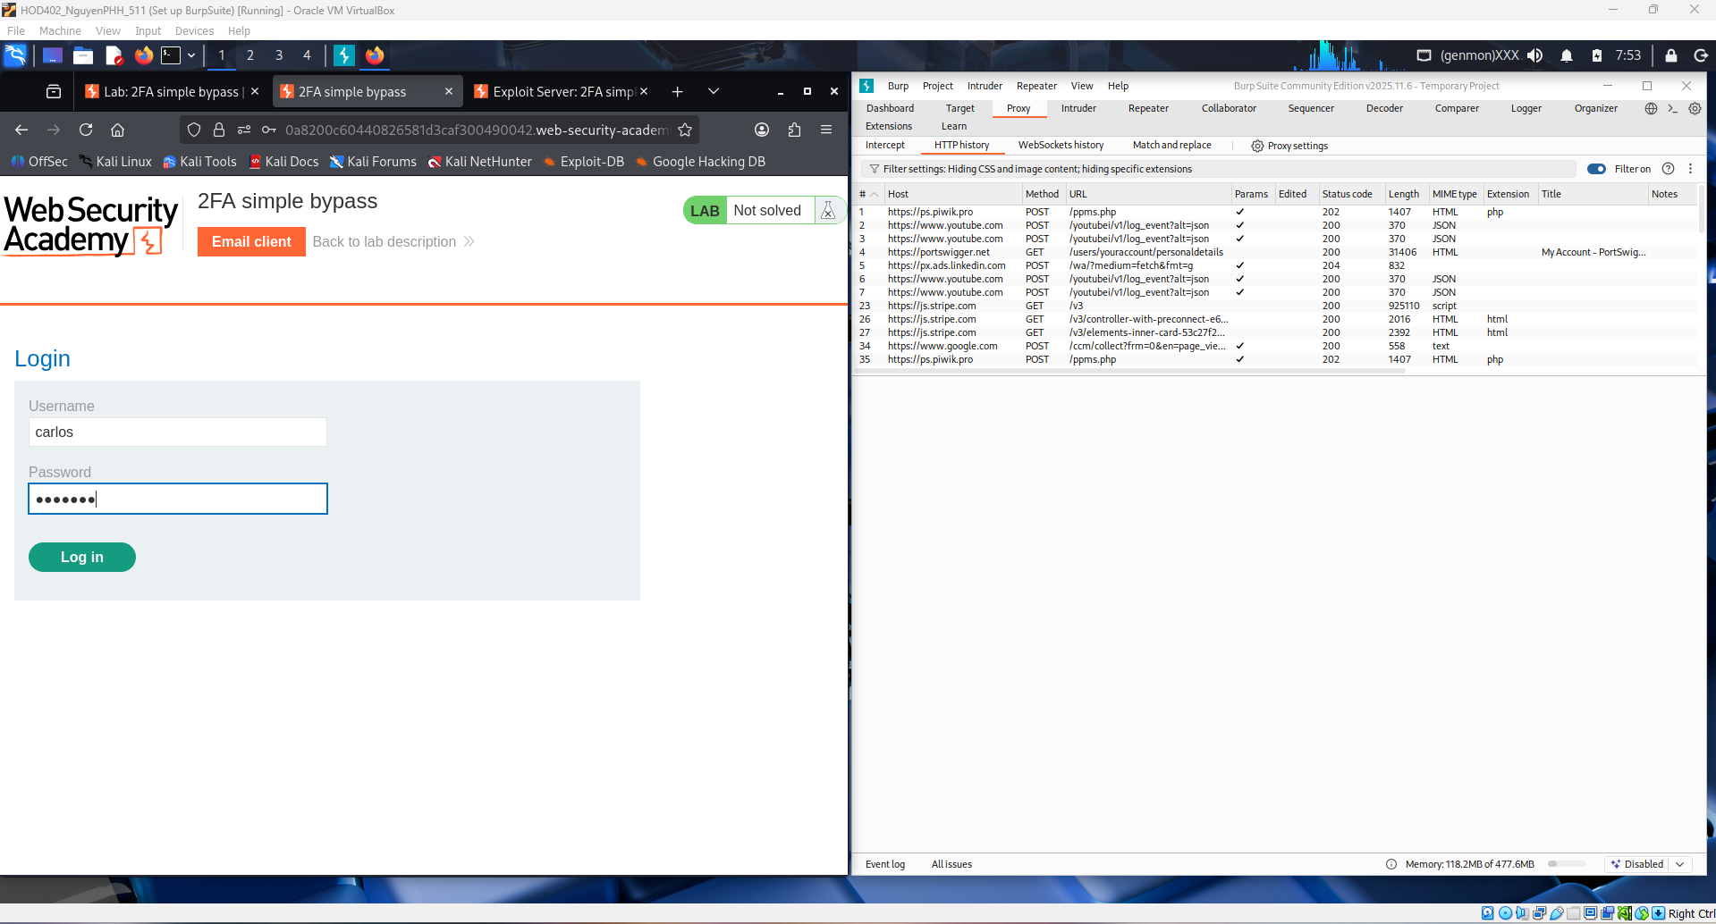
This screenshot shows the second step of login, where the application asks for the 4-digit 2FA security code. After valid username and password authentication, the server prompts for this verification code. This is the stage analyzed in Burp Suite to find the logic flaw that allows the 2FA check to be bypassed.
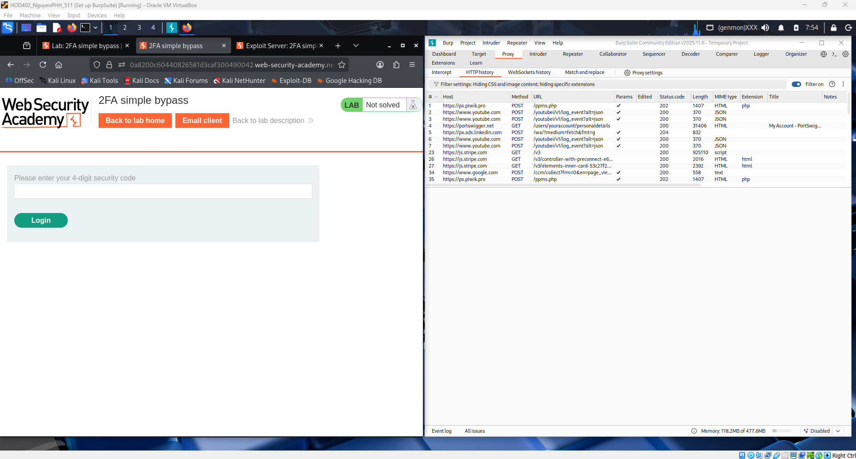
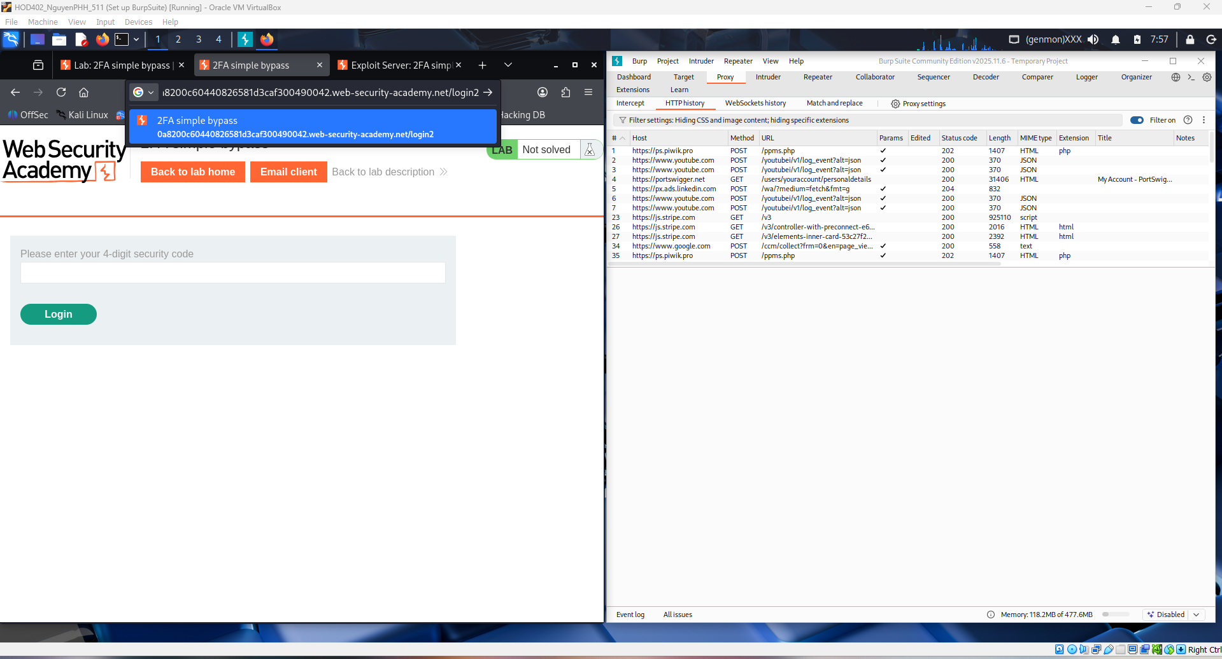
This image shows the browser on the /login2 page of the 2FA simple bypass lab, which is the endpoint responsible for the second-factor verification. It indicates the user has already passed the username/password stage and is now at the 2FA processing step. This endpoint is the key target when analyzing how the application improperly enforces the 2FA check.
This screenshot highlights direct navigation to the /my-account endpoint in the 2FA simple bypass lab. Even though the browser is still on the 2FA code page, accessing this URL suggests the app does not properly verify whether 2FA was completed before granting account access. This demonstrates a logic flaw where authorization relies only on the session from step one.
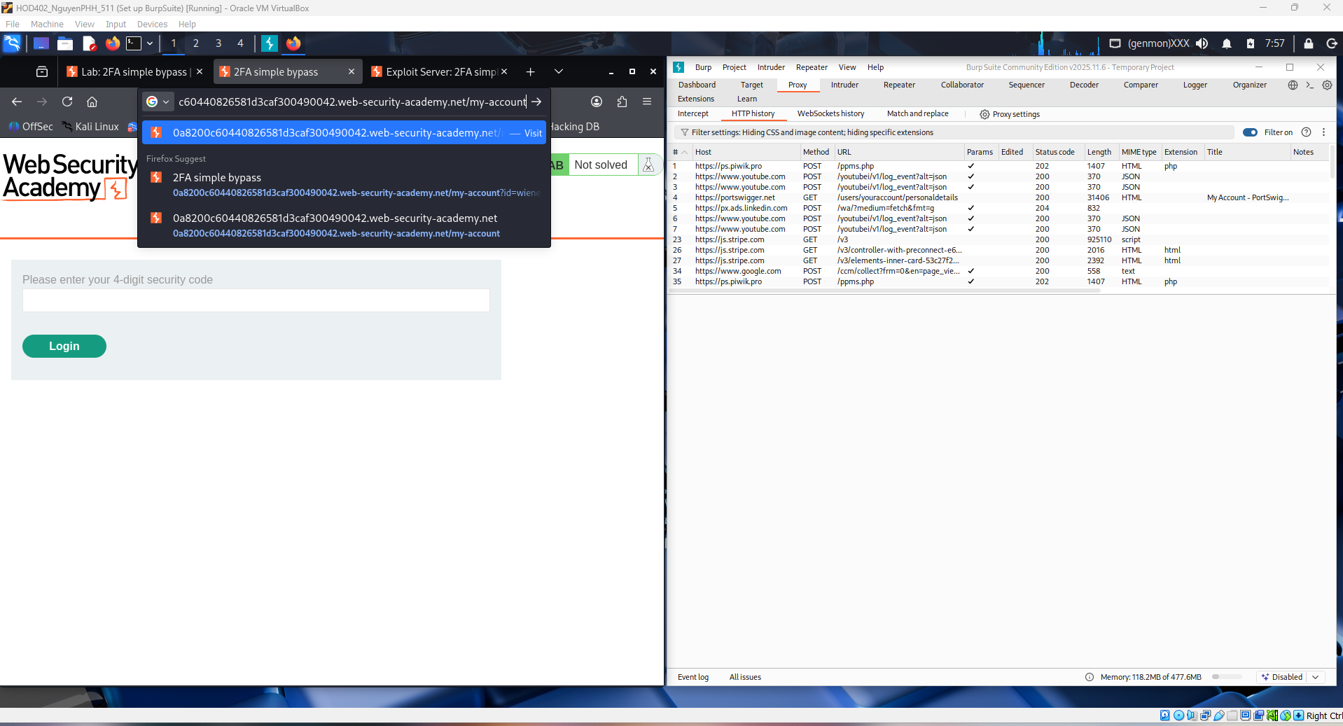
This screenshot shows the lab marked “Solved” after successfully bypassing the 2FA mechanism. The user is logged into Carlos’s account, proving that access was granted without completing proper second-factor verification. It confirms the vulnerability: the application fails to enforce 2FA before allowing access to sensitive endpoints like /my-account.
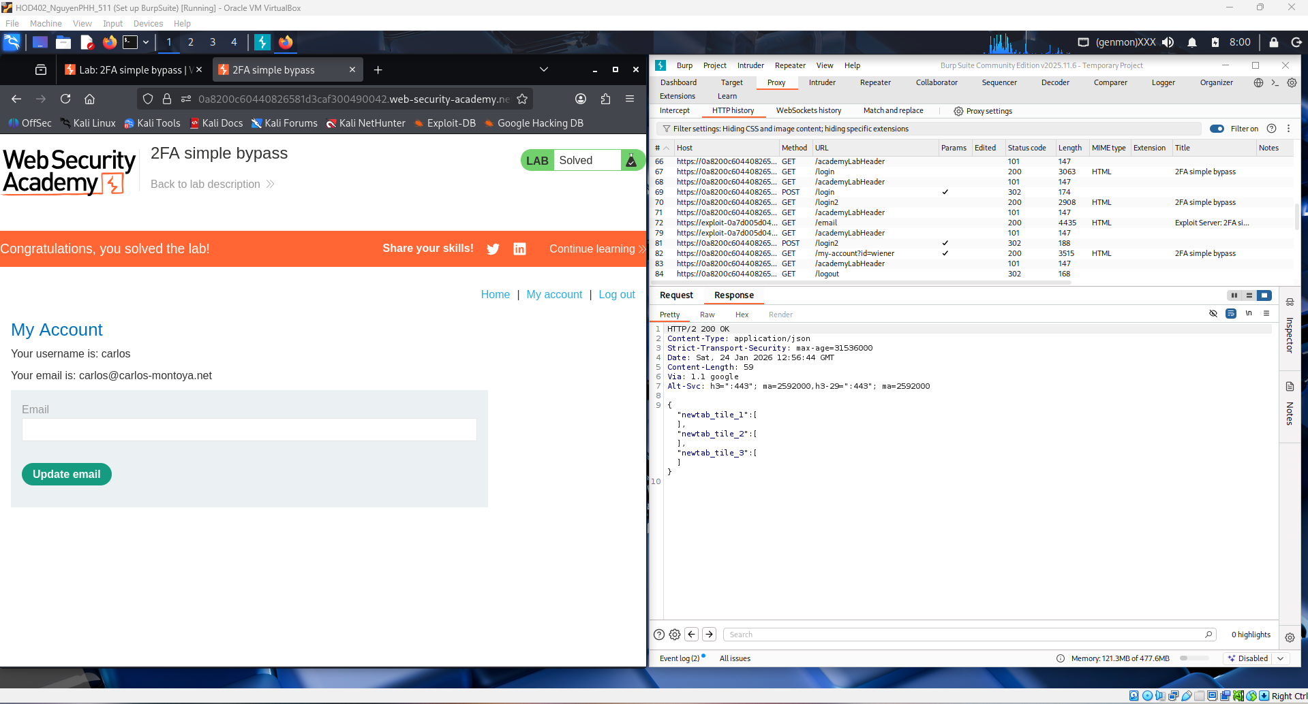

2. 2FA broken logic
This screenshot shows the Web Security Academy lab “2FA broken logic.” The user is on the main blog page while Burp Suite is intercepting traffic for analysis. This lab focuses on a logical flaw in the 2FA workflow, where the verification process can be manipulated due to improper server-side validation of the authentication steps.
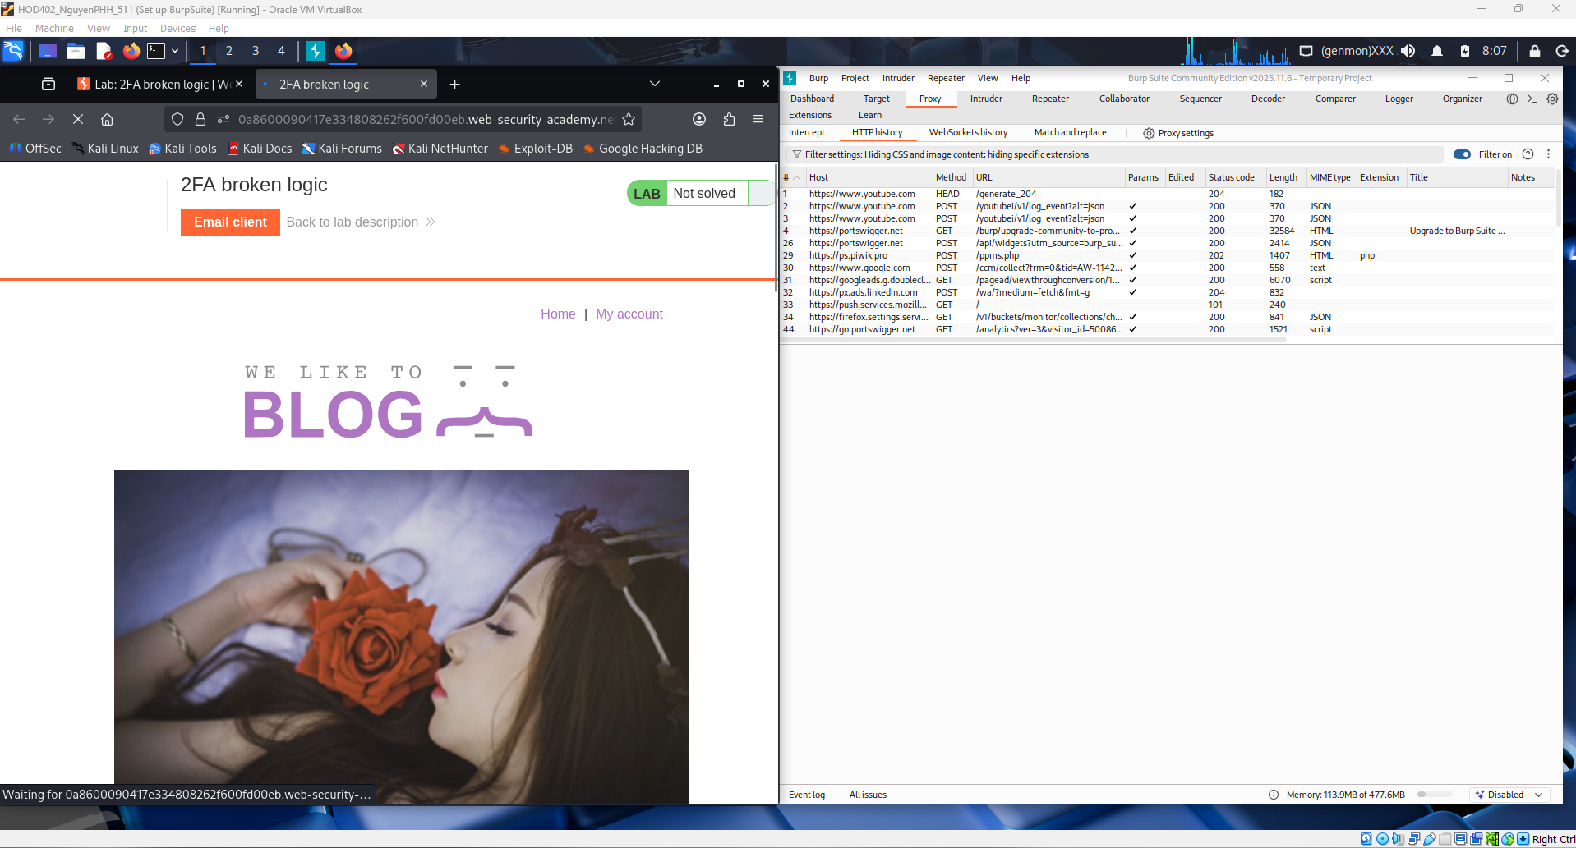
This screenshot shows the login stage of the “2FA broken logic” lab. The user submits the username wiener and password, which is the first authentication step before 2FA is triggered. Burp Suite is ready to capture the requests so the flawed logic in how the app handles the second factor can be analyzed.

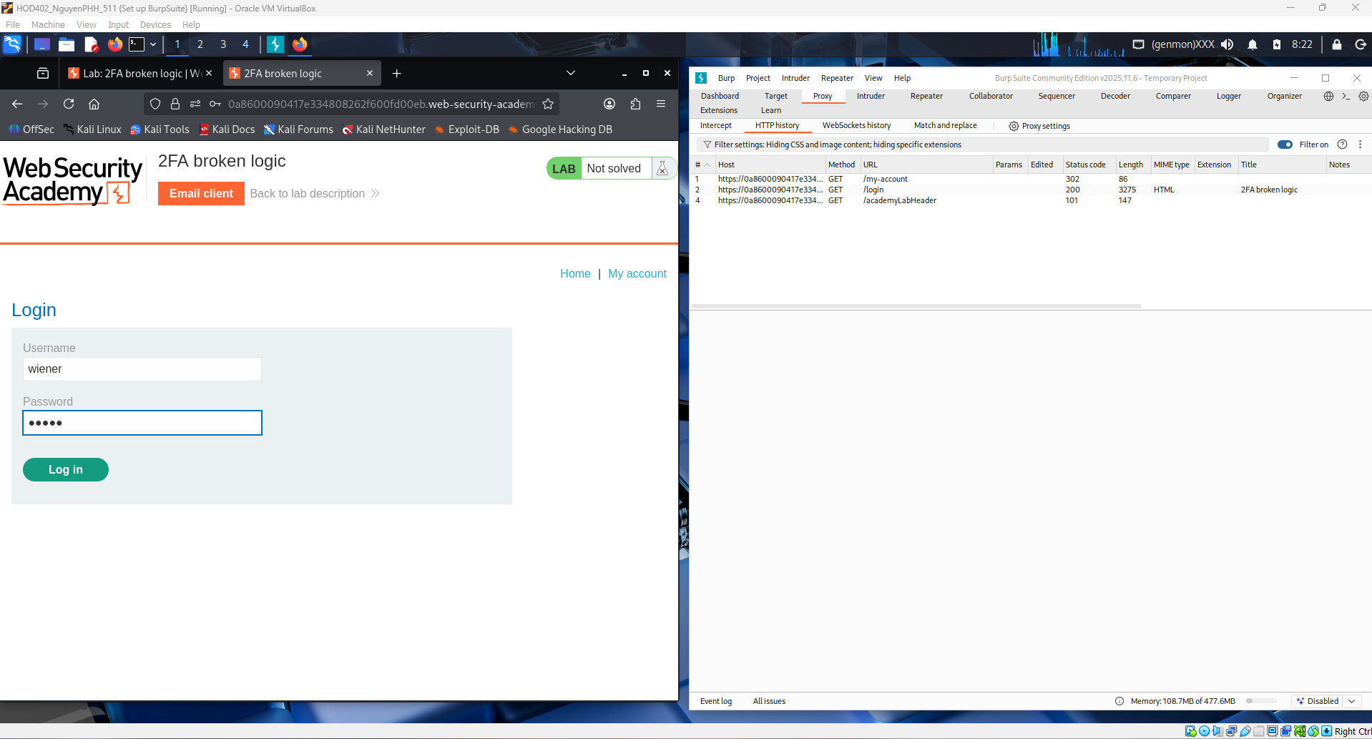
This image shows the 2FA verification page in the “2FA broken logic” lab, where the app asks for a 4-digit security code after correct credentials. This is the second authentication step, and the lab’s vulnerability lies in how the server incorrectly links this step to the user/session, allowing the logic to be abused. Burp Suite is capturing the related requests for analysis.
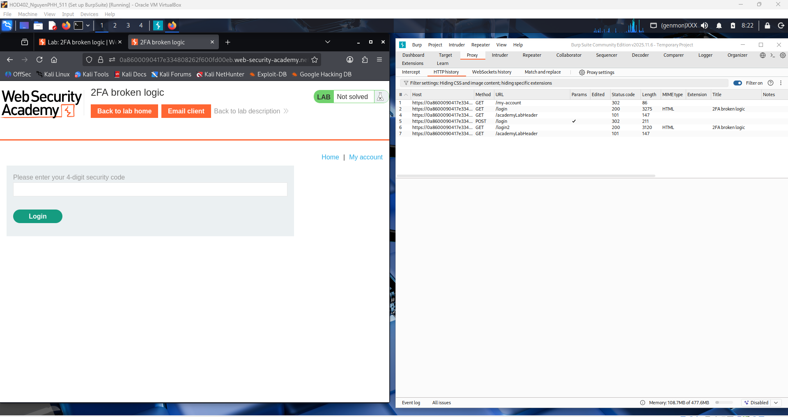
This screenshot shows the exploit server email inbox used in the 2FA broken logic lab. It contains the message sent to wiener, including the 4-digit security code needed for the second authentication step. This demonstrates how the lab provides access to the victim’s 2FA code and sets up the scenario where flaws in the verification logic can be abused.
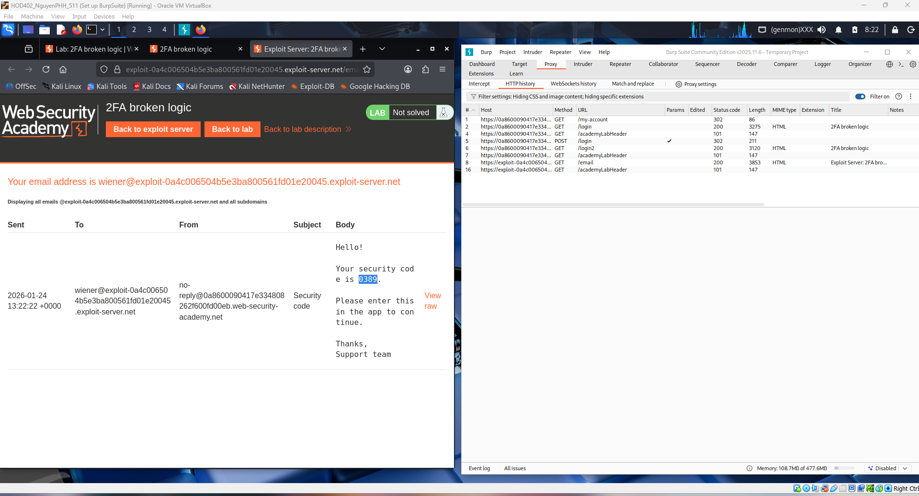
This screenshot shows the user entering the 4-digit security code (0389) on the 2FA verification page in the “2FA broken logic” lab. This step normally completes second-factor authentication, but in this lab the verification process is flawed. Burp Suite is monitoring the request to analyze how the server incorrectly handles the 2FA validation logic.
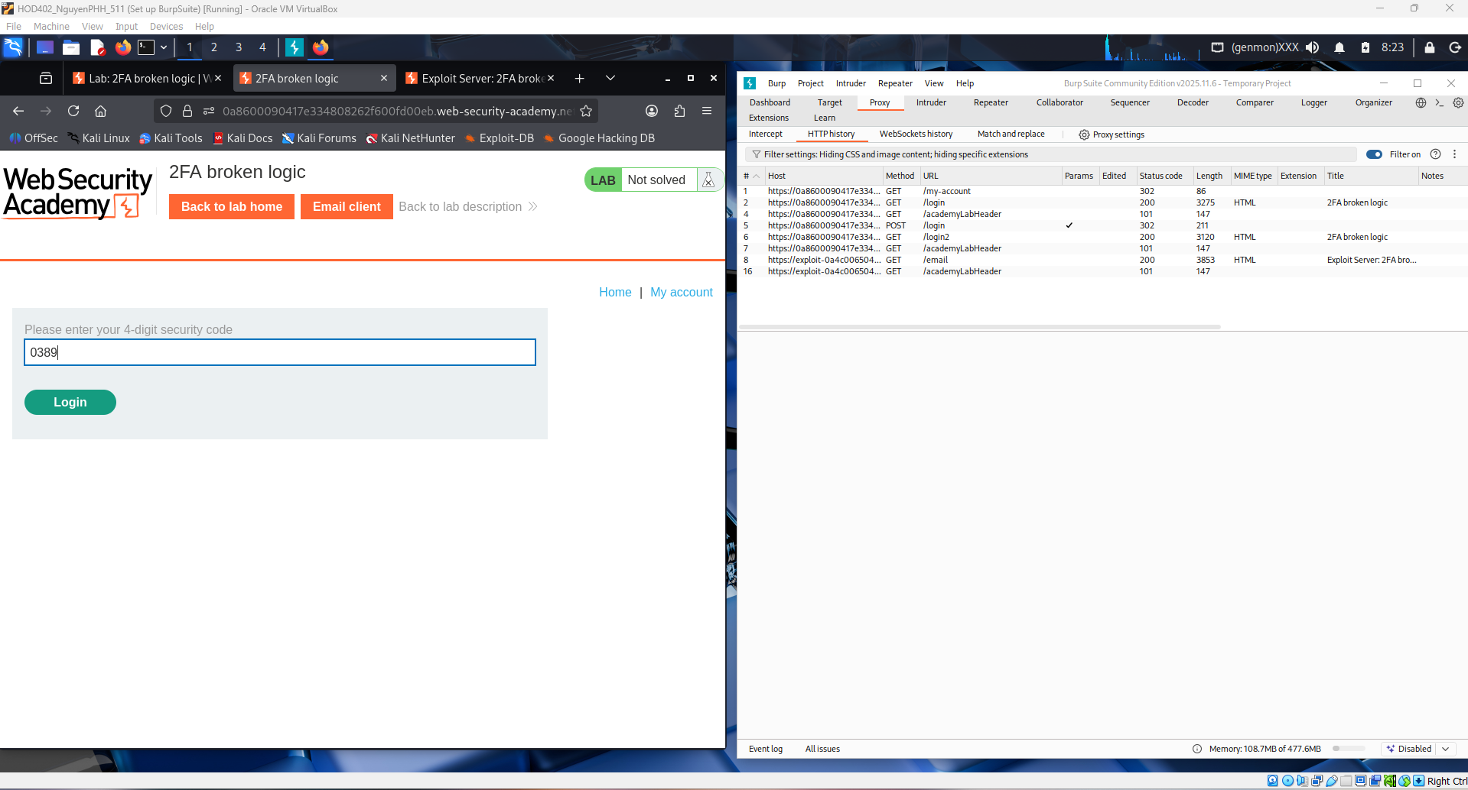
This screenshot shows successful access to the My Account page in the “2FA broken logic” lab after submitting the security code. The session is now authenticated as wiener, meaning the 2FA step was accepted. In this lab, the weakness lies in how the app ties the 2FA verification to the user/session, which can be manipulated due to flawed logic.
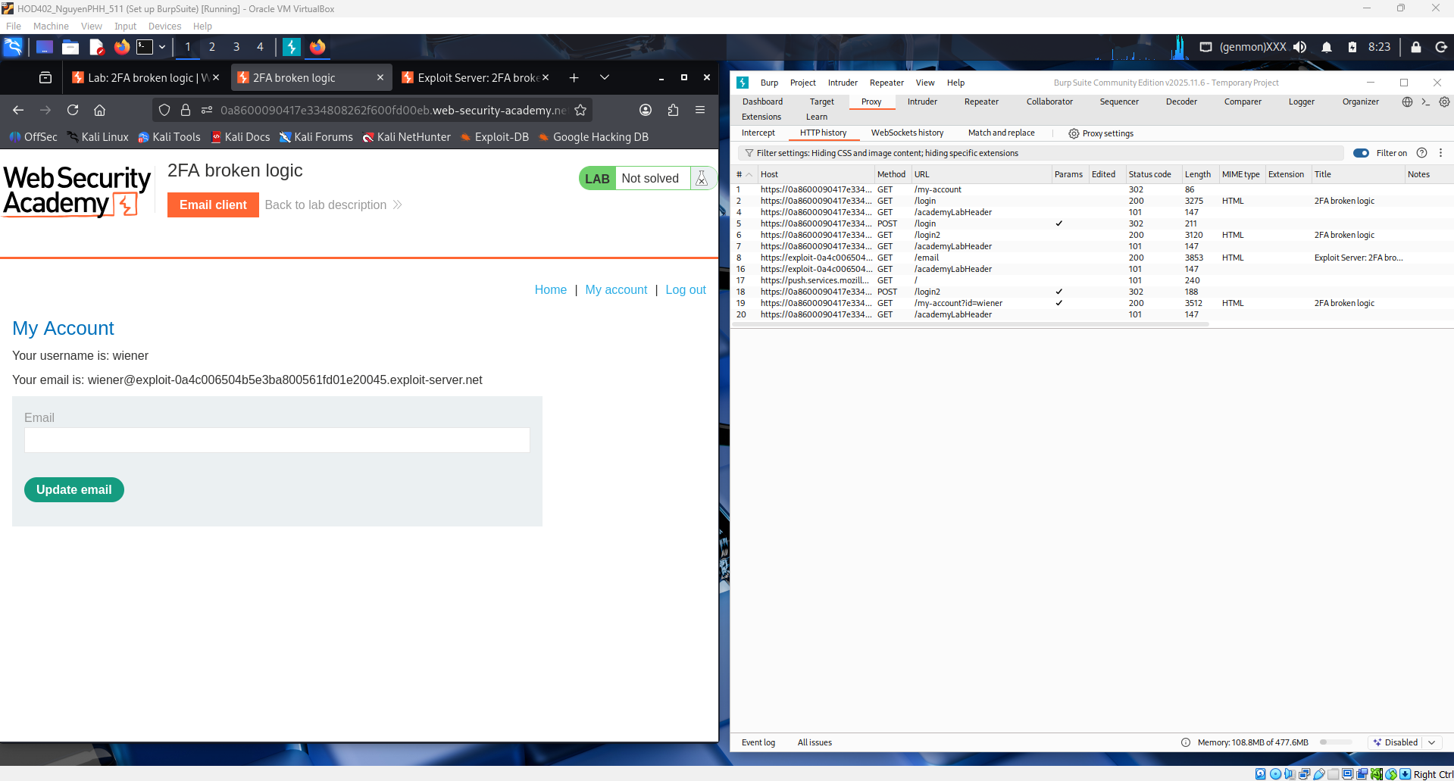
This screenshot shows the authenticated My Account page for wiener in the “2FA broken logic” lab, alongside the captured request in Burp. The request includes the session cookie that proves the server now considers the user fully logged in. The lab’s issue is that the 2FA verification state is handled with flawed logic, allowing authentication flow manipulation.
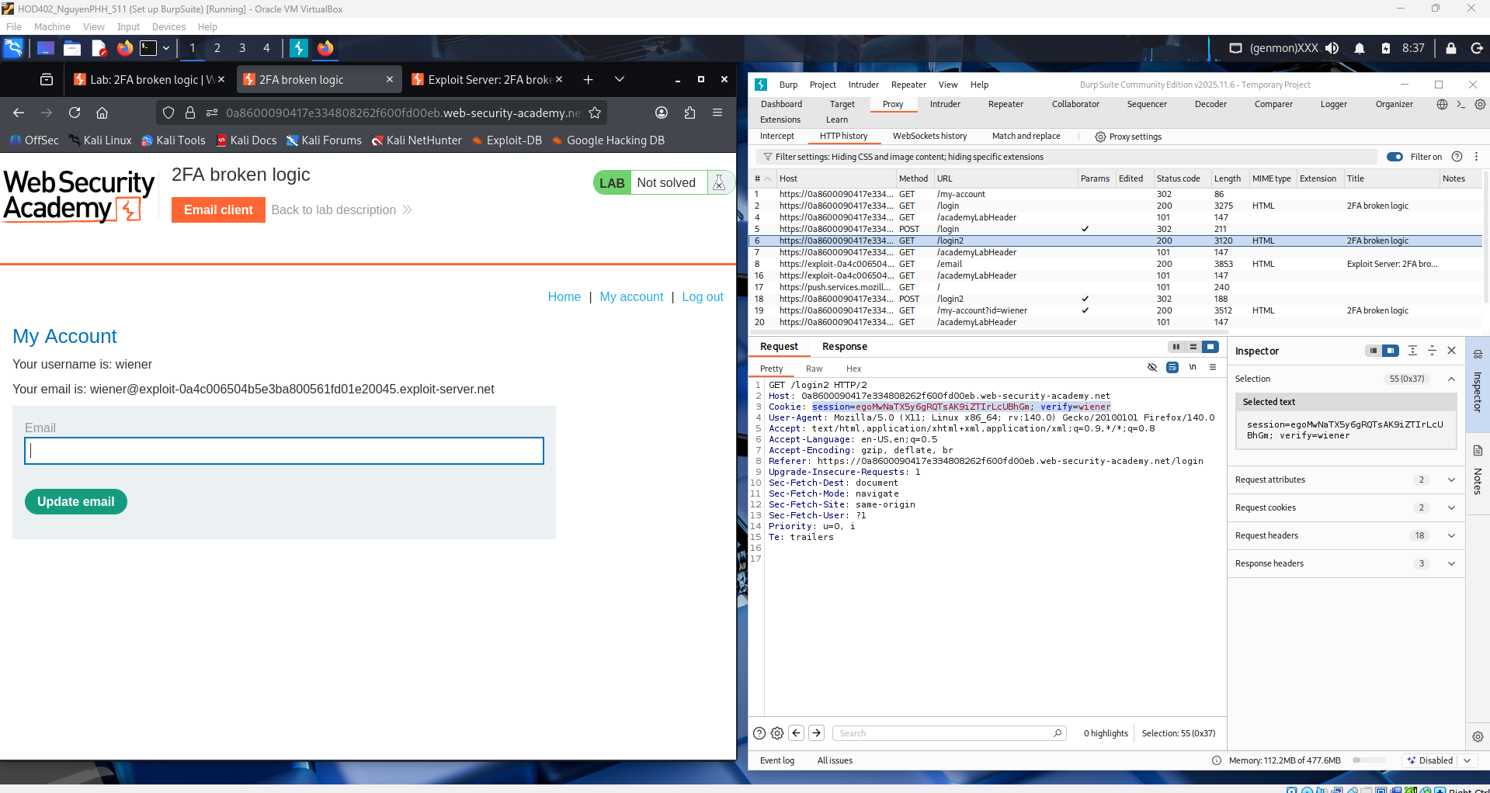
This screenshot shows the /login2 request opened in Burp Repeater during the 2FA broken logic lab. The session cookie and parameters can be modified and resent to test how the server validates the second authentication step. This is where the broken logic can be exploited by manipulating how the app associates the 2FA verification with the authenticated user session.
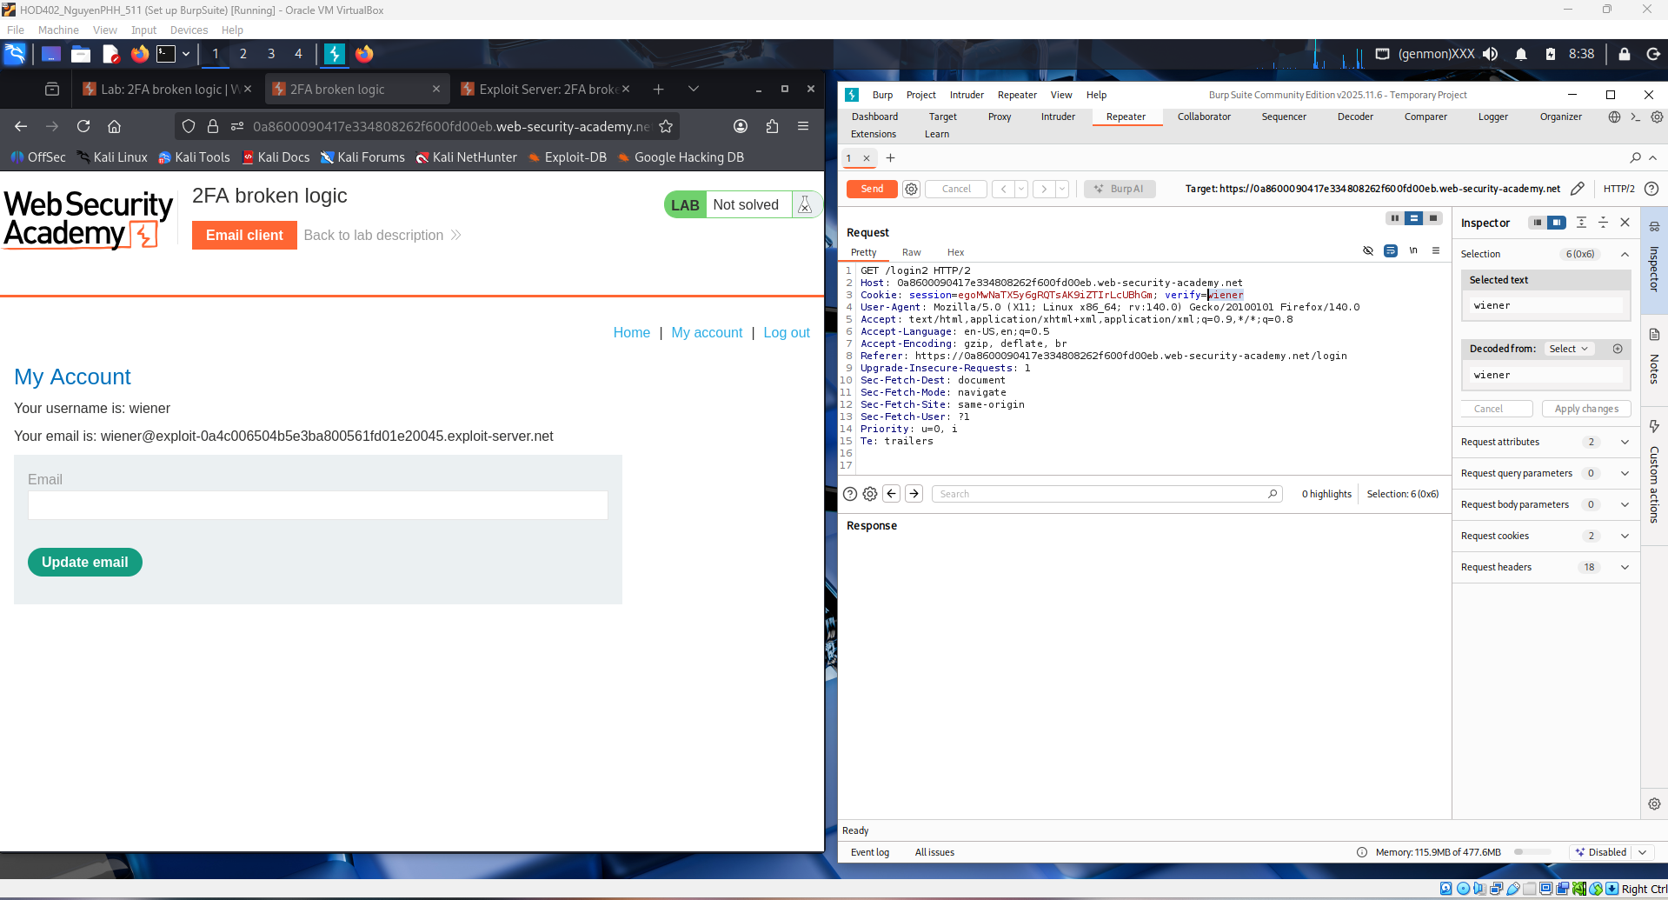
This screenshot shows the modified /login2 request sent from Burp Repeater and receiving a 200 OK response. The server issues a valid session and loads authenticated content even though the 2FA flow can be tampered with. This confirms the broken logic: the application trusts manipulated 2FA state and grants account access without properly enforcing the intended verification sequence.
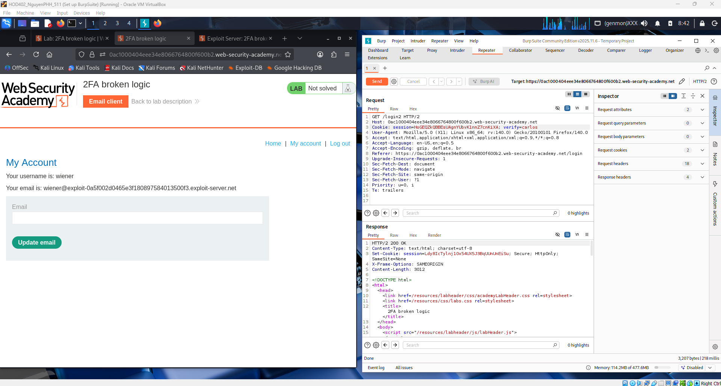
After submitting valid credentials, the server redirects the user to the /login2 endpoint for the second authentication step. A valid session is already established before 2FA verification is completed. This shows the authentication process relies on weak logic, enabling a potential 2FA bypass.
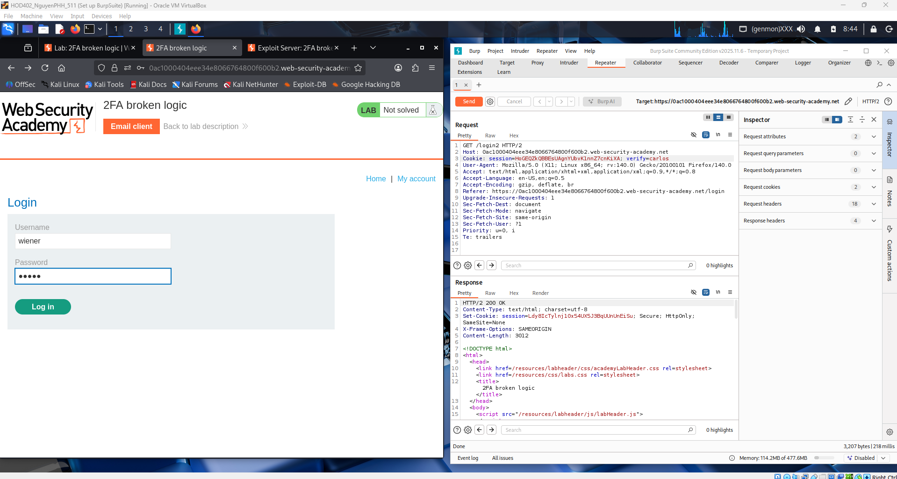
The application asks for a 4-digit 2FA code after the initial login step. However, the session cookie is already valid before the code is verified. This indicates broken authentication logic where the second factor can potentially be bypassed.
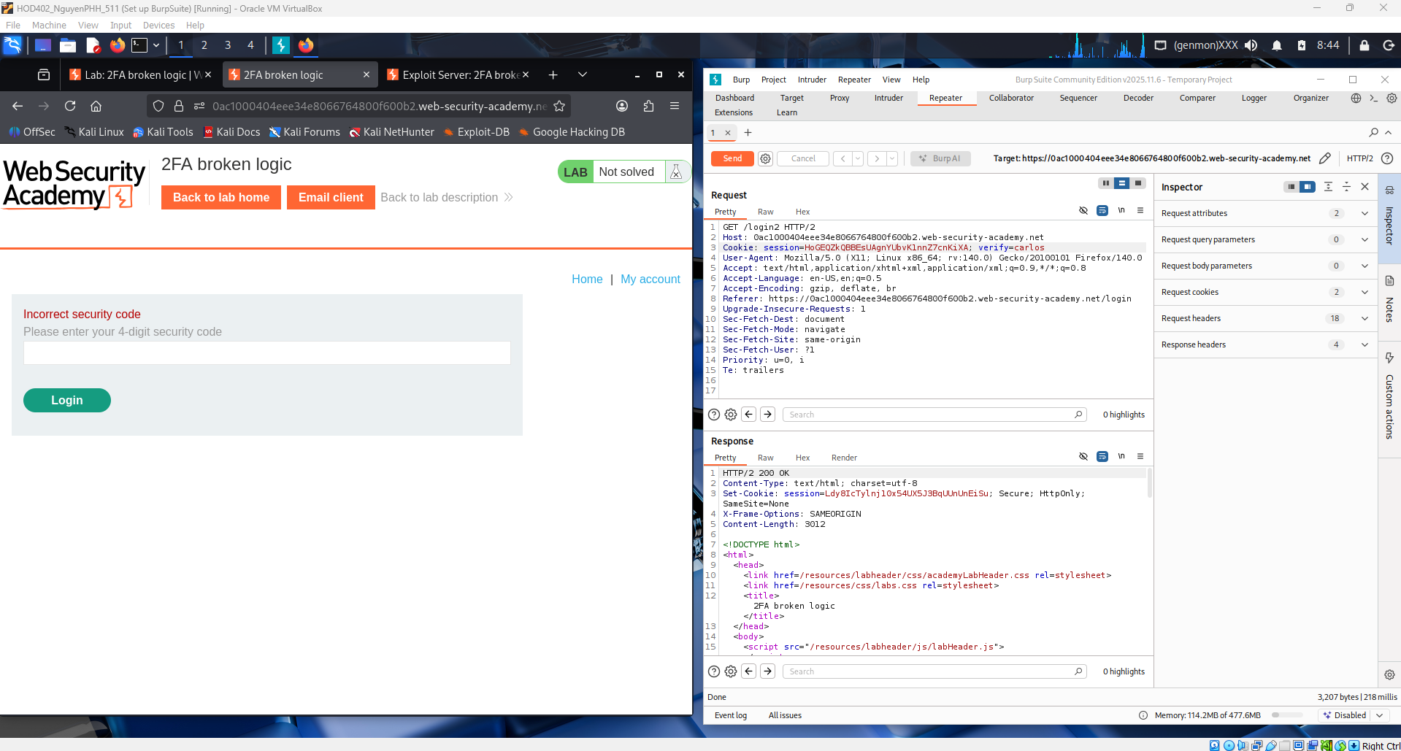
This request shows the POST to /login2 where the 4-digit 2FA code is submitted. Even with an incorrect code, the session cookie from the first login step is still present and active. This confirms the 2FA check is not properly tied to session validation, leading to an authentication bypass flaw.
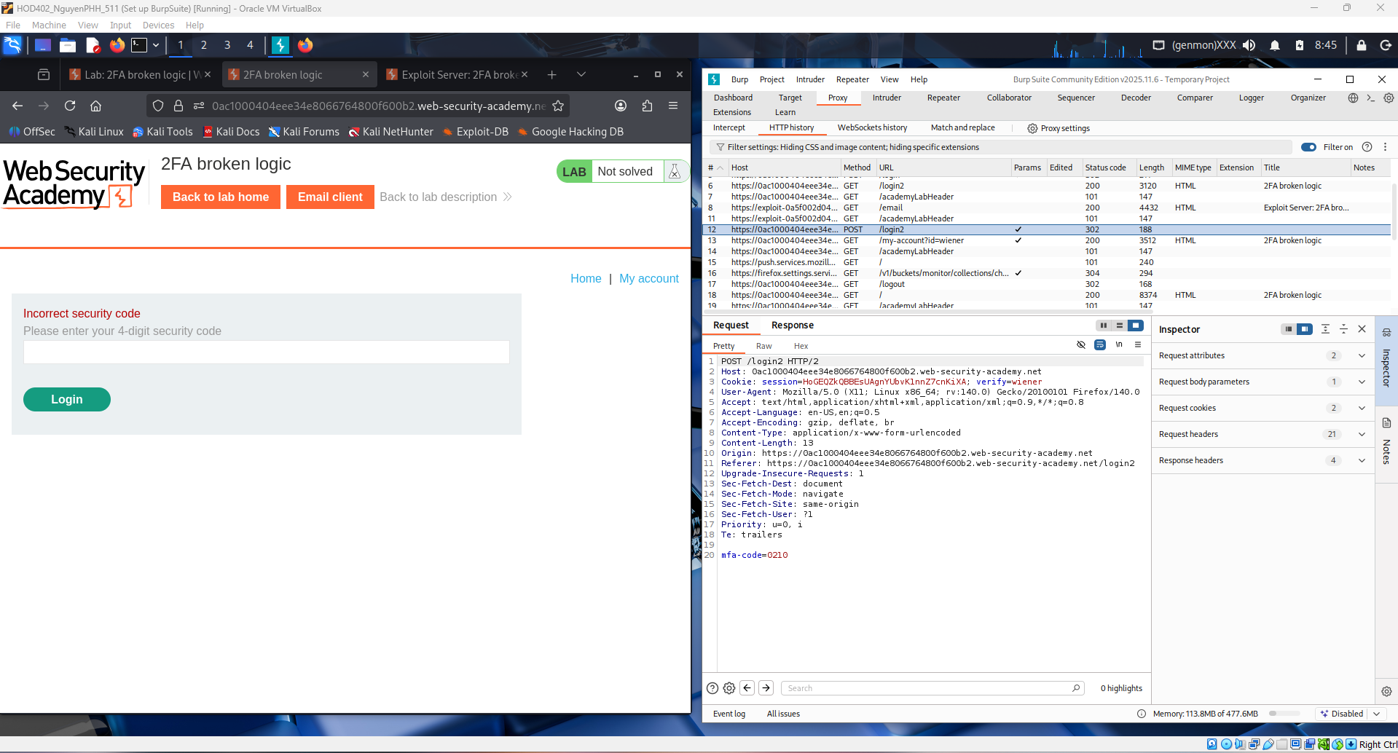
This shows a Burp Intruder brute-force attack against the /login2 2FA endpoint. The payload list is cycling through 4-digit codes (0000–9999) because there’s no rate limiting or account lockout. A different response length/status will reveal the correct code, proving the 2FA can be bypassed by brute force.
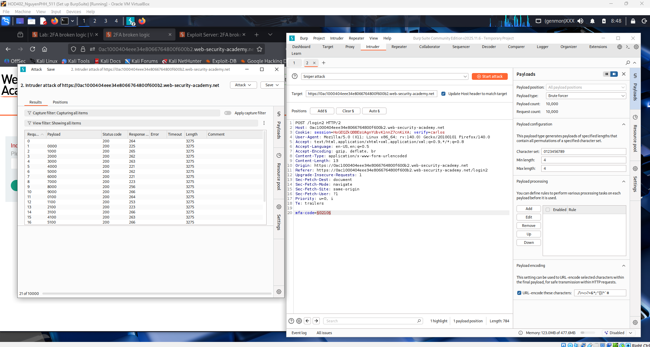
This result shows one payload with a different response length (178) while the others are 307, meaning the server responded differently for that code. That shorter response indicates a successful 2FA guess. So the correct security code is the payload on that row, proving the 2FA is vulnerable to brute-force.
That request has a different response length (178), meaning login succeeded, while others (3057) are failures.
You’re now using “Show response in browser” to load that successful response in your session — this bypasses the 2FA and logs you in, solving the lab.
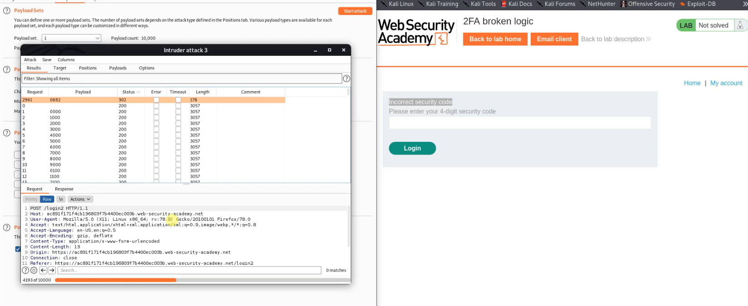
You already identified the correct 2FA code (0692) because that request had a shorter response length (178) compared to the failed ones (3057). That size difference means the server returned a success response.
By choosing “Show response in browser”, you force Burp to load that successful server response into your browser session. The app trusts it, your session becomes authenticated, and you bypass the 2FA check — which completes the Broken Logic 2FA lab.

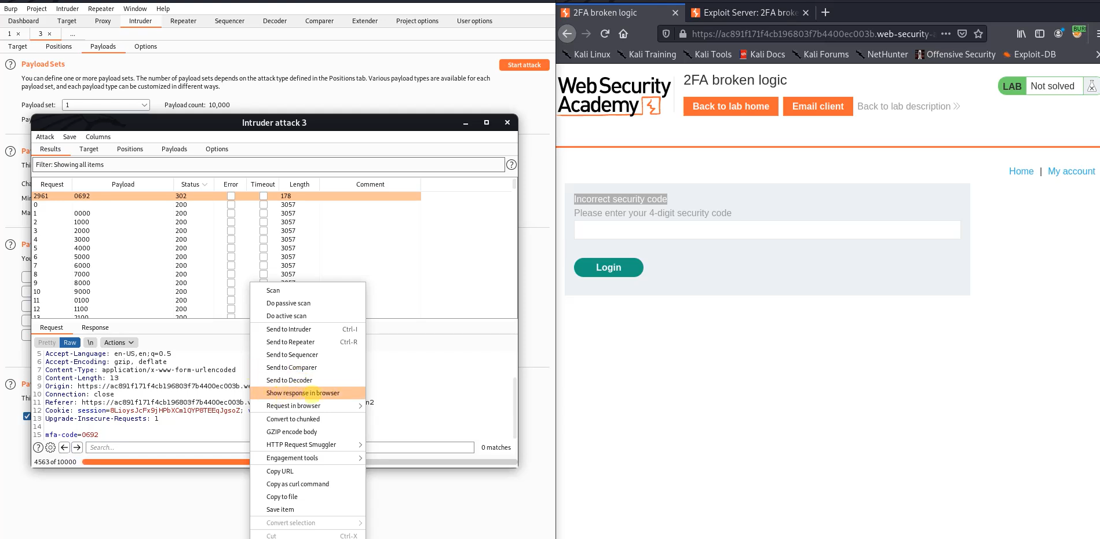

You exploited a logic flaw in the 2FA verification:
- The app didn’t properly limit or protect the 4-digit code → you could brute force it with Burp Intruder.
- A different response length revealed the correct code (0692).
- Replaying that successful response logged you in as carlos, solving the lab.
This is a classic Broken Authentication via weak 2FA logic — not crypto broken, just bad application logic.

